DAILY ONLINE ACTIVITIES SUMMARY

Date: | 30-07-2020 |  |  |  |  |  | Name: |  | Kavya.R.Shetty
Sem & Sec | 6th sem, ‘A’ sec |  |  |  |  |  | USN: |  | 4AL17CS042
 |  |  | Online Test Summary
Subject |  | --
Max. Marks |  | - |  |  | Score |  |  |  | -
 |  |  | Certification Course Summary
Course | Programming for Everybody (Getting Started with Python)
Certificate Provider |  |  | Coursera |  |  | Duration |  |  |  | 7Week
 |  |  | Coding Challenges
Problem Statement: 1 python program
Status: executed
Uploaded the report in GitHub |  |  |  |  |  | Yes
If yes Repository name |  |  |  |  |  | https://github.com/kavya-shetty765/DAILY- STATUS
Uploaded the report in slack |  |  |  |  |  | Yes

Online Certification Course Details:

.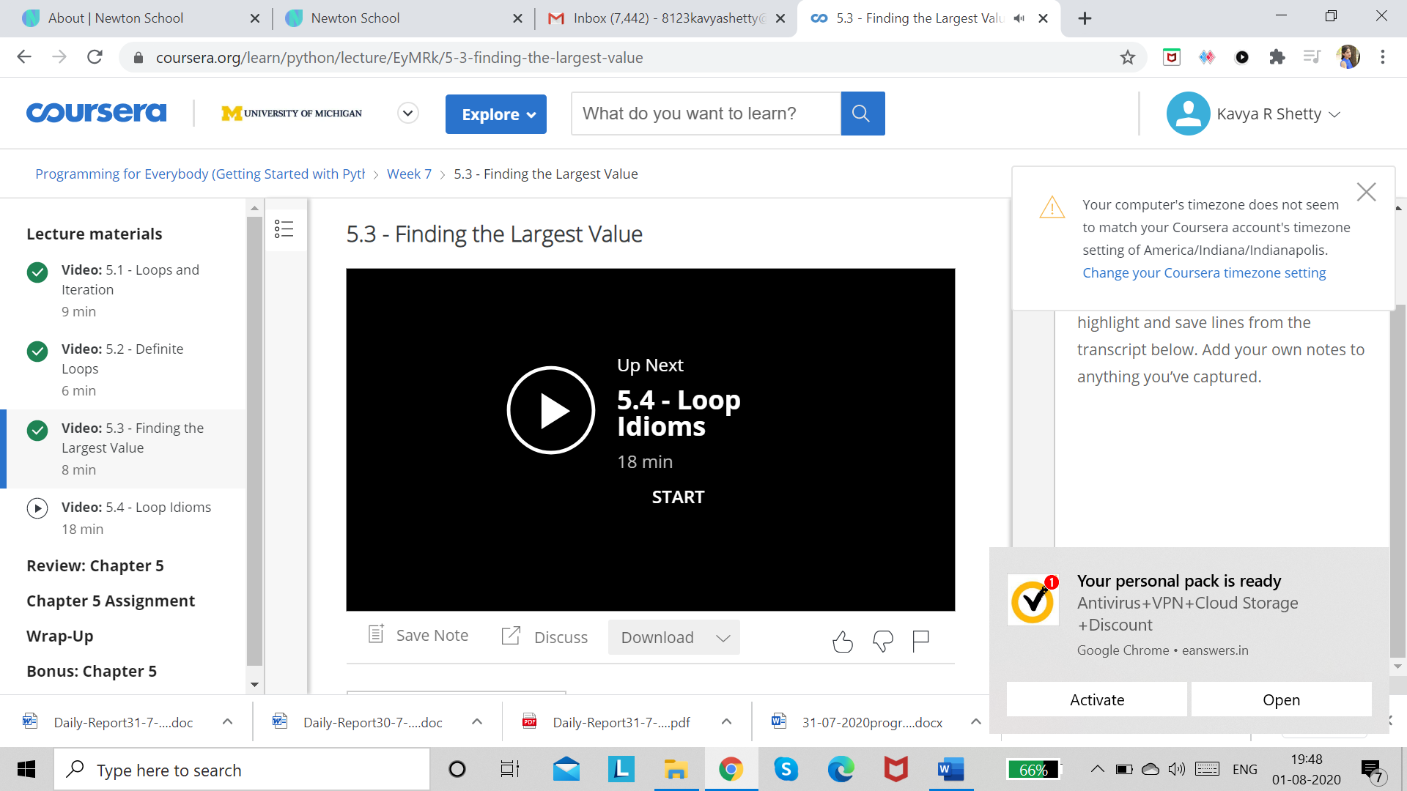

Coding Challenges Details:

Program 1

This is output of python program for Number of stopping station problem
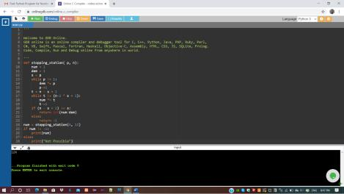

Refer GitHub for detailed Information:

https://github.com/kavya-shetty765/DAILY-STATUS/tree/master/30-07- 2020/ONLINE%20CODING
This Report is also available in:
https://github.com/kavya-shetty765/DAILY-STATUS/blob/master/30.07.2020/DAILY%20REPORT%201.docx

